|  |  |  |  |
| --- | --- | --- | --- |
| lo |  | |  |
|  |  | |  |
|  |  | **Company Name** Street Address  Address 2  City, ST ZIP Code  Web site address | **office@cacphelps.org** |

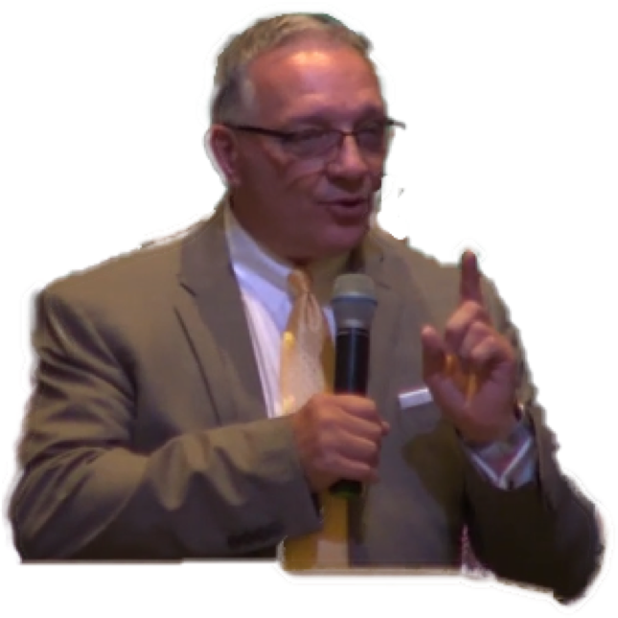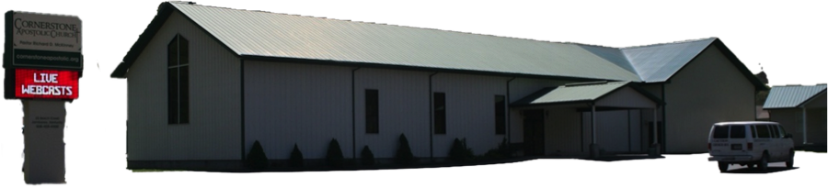

**Connect With Us**

f **@cacphelpsky**

f **@avoptv**

f **@cacdaily**

**@cornerstoneky**

** @cacphelps**

**@cacdaily**

**@avoptv**

**CAC Daily iCasts Weekdays 10am-11am**

***A Little Bit Of Church Everyday, Home Bible Study 21st Century Style***

Coming Up At CAC

* Service at POPC today at 2pm

4754 Raccoon Rd Raccoon KY

* CAC Leadership Team Meetings

2nd Monday of Month @ 7pm

Online via Zoom. Next Zoom Meeting Nov. 9th.

* In Person Services: Sunday School @ 10:30am/Worship Service @ 11am and Wednesdays @ 7pm

|  |
| --- |
|  |
| Trunk Or Treat ‘19  (Whenever Pike Co Designates)  Harvest Time Crusade ‘19  Fri-Sun Nov. 15-17  Fri-Buddy Puckett/Sat-James Chessor/Sun-Ed Tucker |

***SCHEDULE OF REGULAR SERVICES***

*Sunday Morning…………..………………..………..............................................10:30am*

*Sunday Worship Service………………………………………………………………………11:00am*

*Wednesday Evening……………….….................…….……..………………..………....7:00pm*

*Wednesday Youth Service (C.A.C.Y. Wing) and Sunday Evening Service----Postponed*

*During COVID Outbreak. We hope to reboot these services in the near future.*

*EVERYONE WELCOME*

*NOTES & STUFF:*

*__*

*__*

*__*

*__*

*__*

*__*

*__*

*_*

*__*

***The Apostolic Voice Of Phelps Radio Broadcast***

***Sun. 9:30 A.M. - 10:00 A.M.***

***WQHY 95.5 FM***

***The Apostolic Voice Of Phelps TV Ministries***

***TriState CW WQCW-TV Sun. @ 10am***

***MTM/EKB-TV Sun @ 2pm***

***Visit The Church's WebPage at:***

***www.cornerstoneapostolic.org***

***pastor@cornerstoneapostolic.org***

**Experience The Power Of Pentecost!**

# 

# CAC

# Weekly

Sunday, Nov 1, 2020

25 Beech Creek Jamboree KY

Church Office: 606-456-4400

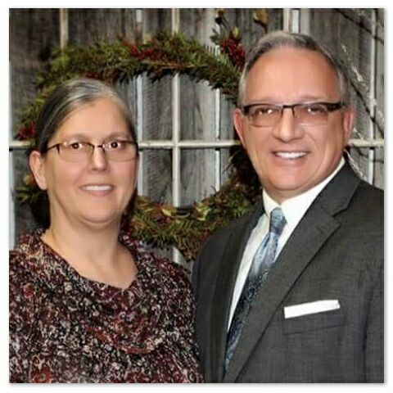

***KY District Section 3***

**Sunday, Nov. 1, 2020**

# Pastor and Sis. McKinney, along with the CAC Church Family, would like to thank you for choosing to worship the Lord with us today.

**We hope you find your visit informative and inspirational and one that will keep you coming back. If you have any questions, feel free to contact our ushers or staff. Connect with CAC today and let CAC be your home church.**

**We hope to see you in future services!**

**_________________________________________**

**Time**

**Ecclesiastes 3:1 To every thing there is a season, and a time to every purpose under the heaven:**

**Time—described in so many ways, such as: We had a good time, we had a great time, what a time, it was a bad time, time for change, time to do better, running out of time, time to turn your clocks back one hour. Yes, time is something we all deal with on a daily basis.**

**Time in Ecclesiastes 3:1 is the Hebrew Word “עֵת ‘êṯ; which also means experiences, occasions, and occurrences. Letting us know that there are going to be occasions for things to come our way. From this we see that there are going to be occurrences of things that happen in our lives. And we all will have experiences in life. Some good, some bad, some happy, some sad, but we will all have *time* happen to us all.**

**Realizing the time we are living in, we see changes in seasons, changes in the world we live in, changes in churches, and changes in our own lives. We have to admit, we all are experiencing a time like we have never seen.**

**The thoughts of turning back time have been wrote about, sung about, and wished upon, only to find it something that is unattainable. Time marches on, time waits for no one, and even later in Ecclesiastes 9:11 we read, “…but time and chance happeneth to them all…”**

**Well, we could go on and on, if we had the *time*. The reality is that time is running out. If you are thinking about serving the Lord, feeling that tug at your heart to give it all to Jesus, then the time is now. Don’t wait for a more convenient time, for you will never find *that* time. Don’t wait for a better time, for there is not a better time. Don’t put off giving your life to Jesus, for you may find time has expired. Usually when we say time has run out, we are referring to lost opportunities, don’t pass up this time, this opportunity, this occasion, for you may not have any time left.**

**Romans 13:11-14 And that, knowing the time, that now it is high time to awake out of sleep: for now is our salvation nearer than when we believed. 12 The night is far spent, the day is at hand: let us therefore cast off the works of darkness, and let us put on the armour of light. 13 Let us walk honestly, as in the day; not in rioting and drunkenness, not in chambering and wantonness, not in strife and envying. 14 But put ye on the Lord Jesus Christ, and make not provision for the flesh, to fulfil the lusts thereof.**

**Don’t forget about time—setting your clock back or setting your life in order.**

**WELCOME**

**TO**

**CAC**

### Cornerstone Apostolic Church

25 Beech Creek ~ PO Box 1093 ~ Phelps, Kentucky 41553

Church Office: 606.456.4400

office@cacphelps.org